Retro ZX Spectrum Game Development
A quick crash course in Z80 assembly
Prepared as a practical primer for returning Spectrum developers.

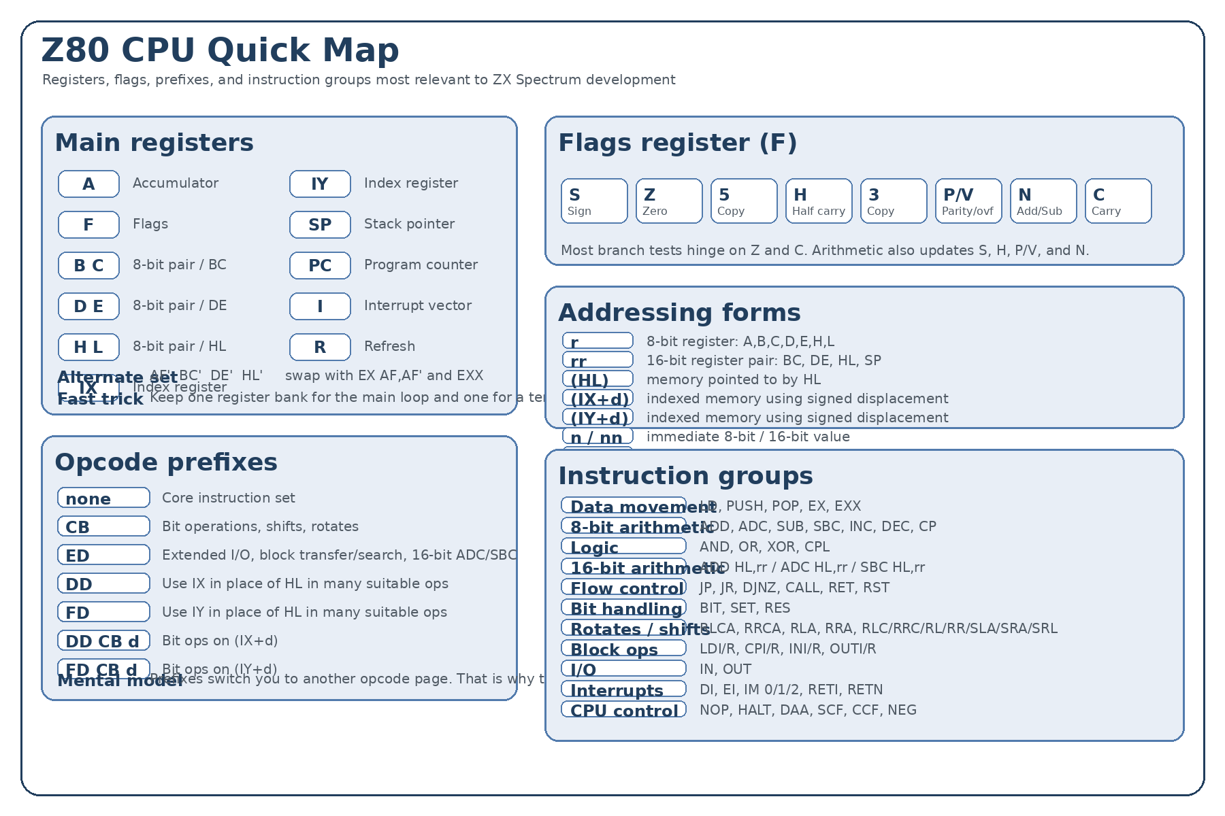
What this gives you | A practical Z80 refresher, tuned for game code, with examples and a compact instruction-set reference.
Best next step | Once this is familiar again, build tiny routines first: a sprite blit, a keyboard read, a timing loop, and a simple game loop.

1. The Z80 in one page
The Z80 is an 8-bit CPU with a very approachable style: load data into registers, do arithmetic or logic, test the flags, and jump when the result tells you to. For Spectrum game work, the art lies in being economical with registers and ruthless about tight loops.
- 8-bit registers: A, B, C, D, E, H, L. The accumulator A is the star of the show.
- 16-bit register pairs: BC, DE, HL. Also SP (stack pointer), PC (program counter), IX and IY (index registers).
- Flags live in F. The most commonly used are Z (zero) and C (carry).
- Memory is byte-addressed. Instructions may use registers, immediates, or memory via (HL), (IX+d), or (IY+d).
- Conditional flow is mostly built from JP, JR, CALL, RET, DJNZ, and tests on the flags.
A good mental model:
Z80 assembly is about moving bytes, shaping flags, and branching at exactly the right moment.

2. Registers and flags
Item | Use in practice
A | Accumulator for arithmetic, logic, comparisons, and lots of data movement.
F | Flags register: S, Z, H, P/V, N, C, plus two undocumented copy bits.
BC / DE / HL | Common 16-bit working pairs. HL is the classic memory pointer.
IX / IY | Indexed pointers, handy but usually slower than HL.
SP | Stack pointer for CALL/RET, PUSH/POP, and temporary storage.
PC | Program counter; usually implicit.
AF' and EXX set | Alternate register bank for very fast context swaps.
Flags worth burning into muscle memory:
Flag | Meaning | Typical use
Z | Zero | Loop termination, equality tests, JP Z / JR Z / RET Z
C | Carry | Unsigned overflow, 16-bit carries, JP C / JR C
S | Sign | Negative result in signed arithmetic
P/V | Parity / overflow | Signed overflow or parity, depending on instruction
N | Subtract flag | Set by subtraction/CP; useful for DAA context
H | Half carry | Mostly relevant for BCD with DAA

3. Syntax and addressing
Common forms you will see again and again:
Form | Example | Meaning
r | LD A,B | 8-bit register
rr | LD HL,40000 | 16-bit register pair
n | LD A,42 | Immediate 8-bit value
nn | LD DE,49152 | Immediate 16-bit value
(HL) | LD A,(HL) | Memory pointed to by HL
(IX+d) | LD A,(IX+3) | Indexed memory with signed displacement
(IY+d) | BIT 0,(IY-1) | Same idea using IY
(nn) | LD A,(23560) | Absolute memory address
Parentheses mean memory access: LD A,(16384) reads the byte stored at address 16384.

4. The core instruction families
You do not need every instruction in your head on day one. You do need the shape of the instruction set.
Family | Key mnemonics | Why it matters
Load / exchange | LD, PUSH, POP, EX, EXX | Moves data around and preserves state.
8-bit arithmetic | ADD, ADC, SUB, SBC, INC, DEC, CP | Score logic, counters, comparisons, collision math.
Logic | AND, OR, XOR, CPL | Masking bits, toggles, fast clears, comparisons.
16-bit arithmetic | ADD HL,rr / ADC HL,rr / SBC HL,rr | Pointer math and counters.
Flow control | JP, JR, DJNZ, CALL, RET, RST | Loops, branches, subroutines.
Bit ops | BIT, SET, RES | Game-state flags, keyboard masks, sprite attributes.
Rotate / shift | RLCA, RLA, RRCA, RRA, RLC, RRC, RL, RR, SLA, SRA, SRL | Bit scrolling, packed data, fast multiply/divide by powers of two.
I/O | IN, OUT | Useful when talking to hardware and peripherals.
Block ops | LDI, LDIR, CPI, CPIR, INI, OTIR, etc. | Fast repeated memory or port work.
Interrupt / CPU control | DI, EI, IM, NOP, HALT, DAA, SCF, CCF, NEG | System-level control and arithmetic edge cases.

5. Tiny examples that bring it back

A. Count down a loop
LD B,10 ; loop count

Loop:
; do something useful here
DJNZ Loop ; decrement B and jump if not zero
DJNZ is gold for small loops. It is compact and quick.

B. Compare and branch
LD A,(PlayerX)
CP 120 ; compare A with 120
JR C,StillLeft ; jump if A < 120 (unsigned compare)
CP subtracts internally, sets flags, and throws the result away.

C. Copy bytes with HL, DE, BC
LD HL,Source
LD DE,Dest
LD BC,32

CopyLoop:
LD A,(HL)
LD (DE),A
INC HL
INC DE
DEC BC
LD A,B
OR C
JR NZ,CopyLoop
This is the classic manual copy pattern. Later, you may switch to LDIR when appropriate.

D. Toggle bits with XOR
LD A,(Flags)
XOR %00000100
LD (Flags),A
XOR is perfect for toggling individual bits when the mask is known.

6. Z80 habits that pay off in games
- Prefer HL for hot memory pointers. IX and IY are convenient but not cheap.
- Use A fearlessly. Many instructions naturally revolve around it.
- Use DJNZ for short counted loops.
- Keep an eye on what destroys flags. A beautiful compare is useless if you clobber Z or C before the branch.
- PUSH and POP are useful, but stack abuse in an inner loop can get expensive.
- EXX and EX AF,AF' are extremely handy when you want a fast temporary register swap.
- Measure ideas against the Spectrum's video memory layout. Sometimes the data layout matters more than the instruction choice.

7. ZX Spectrum specifics worth remembering
The CPU is a Z80A running at roughly 3.5 MHz. On the 48K machine, the bitmap display starts at 16384 and attributes start at 22528. The bitmap is not laid out as a simple linear frame buffer; scan lines are interleaved in the famous Spectrum way. That means plotting and sprite work usually benefits from helper routines or precomputed tables.
- Screen bitmap: 16384–22527
- Colour attributes: 22528–23295
- ROM routines can save time during experimentation, but many fast games eventually replace hot paths with custom code.
- Interrupt timing and contention matter once you start pushing animation or music hard.

8. Prefixes: why some instructions look strange
The base opcode set is only part of the story. Prefix bytes extend or redirect instruction decoding.
Prefix | Effect
CB | Bit, rotate, and shift instruction page
ED | Extended page: block ops, extra I/O, 16-bit ADC/SBC, NEG, RETI/RETN, IM
DD | Use IX in place of HL in many suitable instructions
FD | Use IY in place of HL in many suitable instructions
DD CB d / FD CB d | Indexed bit operations using displacement d
This is why a full opcode map becomes large quickly: the instruction set is really a family of instruction pages.

9. Appendix A — condensed instruction-set reference
This appendix is a mnemonic/form reference. It is meant to be practical rather than byte-for-byte exhaustive. If you want, I can turn this into a full opcode matrix next.

8-bit load
Forms included
LD r,r'
LD r,n
LD r,(HL)
LD r,(IX+d)
LD r,(IY+d)
LD (HL),r
LD (IX+d),r
LD (IY+d),r
LD (HL),n
LD (IX+d),n
LD (IY+d),n
LD A,(BC)
LD A,(DE)
LD A,(nn)
LD (BC),A
LD (DE),A
LD (nn),A
LD A,I
LD A,R
LD I,A
LD R,A

16-bit load / stack / exchange
Forms included
LD rr,nn
LD HL,(nn)
LD rr,(nn) [ED page variants]
LD (nn),HL
LD (nn),rr [ED page variants]
LD SP,HL
LD SP,IX
LD SP,IY
PUSH qq
POP qq
EX DE,HL
EX AF,AF'
EXX
EX (SP),HL
EX (SP),IX
EX (SP),IY

8-bit arithmetic / compare
Forms included
ADD A,r
ADD A,n
ADD A,(HL)
ADD A,(IX+d)
ADD A,(IY+d)
ADC A,r
ADC A,n
ADC A,(HL)
ADC A,(IX+d)
ADC A,(IY+d)
SUB r
SUB n
SUB (HL)
SUB (IX+d)
SUB (IY+d)
SBC A,r
SBC A,n
SBC A,(HL)
SBC A,(IX+d)
SBC A,(IY+d)
INC r
INC (HL)
INC (IX+d)
INC (IY+d)
DEC r
DEC (HL)
DEC (IX+d)
DEC (IY+d)
CP r
CP n
CP (HL)
CP (IX+d)
CP (IY+d)

Logic / misc accumulator
Forms included
AND r/n/(HL)/(IX+d)/(IY+d)
OR r/n/(HL)/(IX+d)/(IY+d)
XOR r/n/(HL)/(IX+d)/(IY+d)
CPL
DAA
SCF
CCF
NEG

16-bit arithmetic
Forms included
ADD HL,rr
ADD IX,pp
ADD IY,rr
INC rr
DEC rr
ADC HL,rr
SBC HL,rr

Rotate / shift
Forms included
RLCA
RLA
RRCA
RRA
RLC r/(HL)/(IX+d)/(IY+d)
RL r/(HL)/(IX+d)/(IY+d)
RRC r/(HL)/(IX+d)/(IY+d)
RR r/(HL)/(IX+d)/(IY+d)
SLA r/(HL)/(IX+d)/(IY+d)
SRA r/(HL)/(IX+d)/(IY+d)
SRL r/(HL)/(IX+d)/(IY+d)

Bit operations
Forms included
BIT b,r
BIT b,(HL)
BIT b,(IX+d)
BIT b,(IY+d)
SET b,r
SET b,(HL)
SET b,(IX+d)
SET b,(IY+d)
RES b,r
RES b,(HL)
RES b,(IX+d)
RES b,(IY+d)

Flow control
Forms included
JP nn
JP cc,nn
JP (HL)
JP (IX)
JP (IY)
JR e
JR C,e
JR NC,e
JR Z,e
JR NZ,e
DJNZ e
CALL nn
CALL cc,nn
RET
RET cc
RETI
RETN
RST p

Block transfer / search
Forms included
LDI
LDIR
LDD
LDDR
CPI
CPIR
CPD
CPDR

Input / output
Forms included
IN A,(n)
IN r,(C)
INI
INIR
IND
INDR
OUT (n),A
OUT (C),r
OUTI
OTIR
OUTD
OTDR

Interrupt / CPU control
Forms included
DI
EI
IM 0
IM 1
IM 2
NOP
HALT

10. Appendix B — what to practise first
- Write a routine that fills 32 bytes of memory with a value.
- Write a loop that animates a byte left and right using RLCA and RRCA.
- Read a keyboard-related byte and test individual bits with BIT.
- Build a sprite or character copy loop using HL, DE, and BC.
- Write a compact delay loop and then replace it with frame-based timing.
If you want, the next document can be a ZX Spectrum-specific sequel: screen memory, attributes, keyboard scanning, interrupts, timing, and a tiny game loop skeleton.

